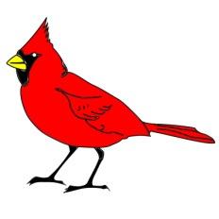
3rd Grade Level Expectations

Students…
- Be Respectful of Everyone and Everything at All Times
  - Keep your hands and feet to yourself
    - Hands behind back or in pockets while in hallway
  - Speak kindly and with inside voices
  - Comply with adult instructions
    - 6-8 grade lanyards on at all times
    - Cell phones in backpacks upon entrance to school building
    - Tardy means not being in your seat when the bell rings
  - Keep the school clean

- Be Responsible for Your Actions
  - Attend school
  - Complete assignments on time
  - Come prepared to learn
  - Follow school specific expectations
  - Take pride in your work

Consequences for Not Following Expectations
- Calm Corner/Mindfulness
- Incomplete homework = Loss of partial recess
- Think It Over Sheet
- Phone Call Home by Student/Teacher
- Lunch Detention
- Alternative Breakfast/Lunch
- Alternative Study
- Suspension

Rewards for Following Expectations
- Quarterly
  - Carindal Tweet Party
- Weekly
  - Cardinal Tweets
- Daily
o Classroom incentives

Homeroom/Study Skills
- Academic Vocabulary (2x per week)
- Restorative Circles (2x per week)
- Binder Check/ Grades 4-8 (Every Friday)

Monday | Tuesday | Wednesday | Thursday | Friday
Circles | Vocab |  | Vocab | Circles

